BAŞKENT ÜNİVERSİTESİ
ELEKTRİK-ELEKTRONİK MÜHENDİSLİĞİ BÖLÜMÜ

EEM 301 Sinyaller ve Sistemler 1

MATLAB PROJESİ

Öğrencinin Adı :Akın Yılmaz
Öğrencinin Numarası : 20494846

20494846
1.3
a.
nx=[-3:7];
x=[0 0 0 2 0 1 -1 3 0 0 0];
stem(nx,x)
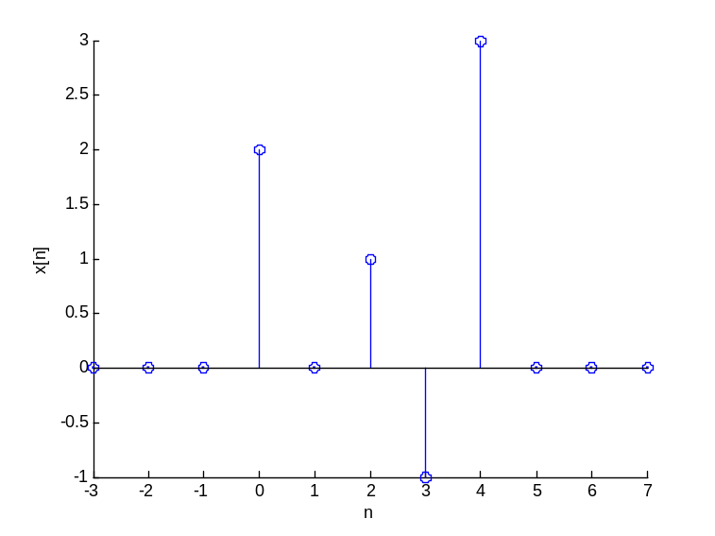
b.
nx=[-3:7];
x=[0 0 0 2 0 1 -1 3 0 0 0];
ny1=[-1:9];
ny2=[-4:6];
ny3=[-7:3];
ny4=[-8:2];
y1=x;
y2=x;
y3=x;
y4=x;

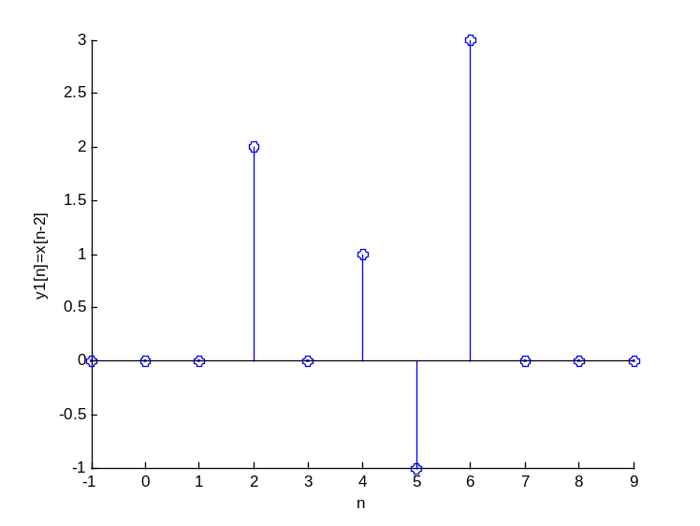
20494846

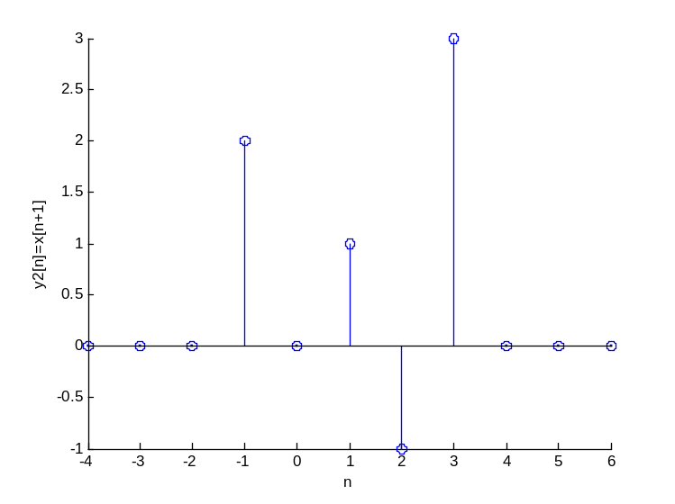

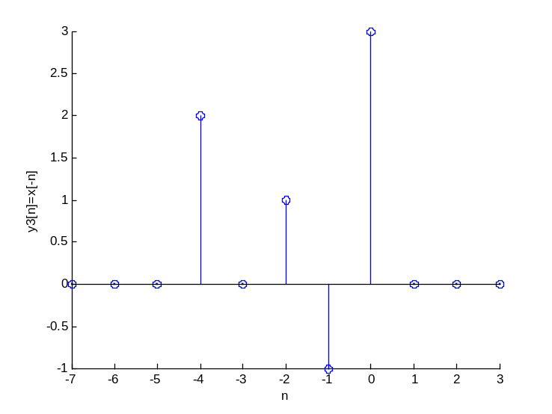
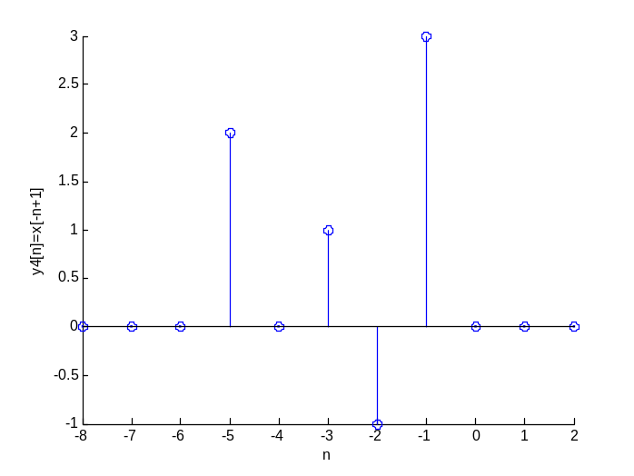
20494846

2.1

a. 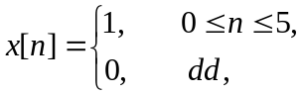 Analitik olarak incelemesi

b. n = [0:5];
x = [1 1 1 1 1 1];
y = conv(x,x);
ny=[0 1 2 3 4 5 6 7 8 9 10];
stem(ny,y)

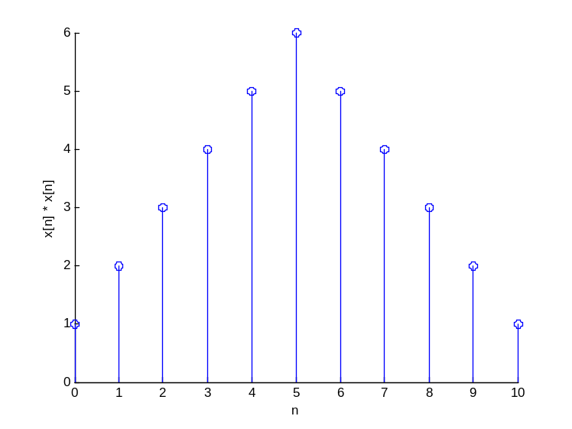
c.
n = [0:5];
h = n;
x = [1 1 1 1 1 1];
y = conv(x,h);
ny = [0 1 2 3 4 5 6 7 8 9 10];
stem(ny,y)
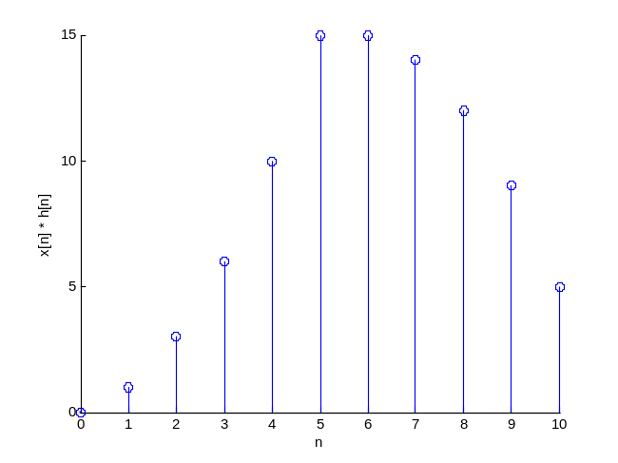
20494846
d.

nx=[0:5];
x=[1 1 1 1 1 1];

nh1=[0:5];

nh=nh1-5;
h=nh+5;

y=conv(x,h);

ny=[-5:5];

stem(ny,y)
title('y[n] = x[n] * h[n+5]');
xlabel('n');
ylabel(' x[n] * h[n+5]');

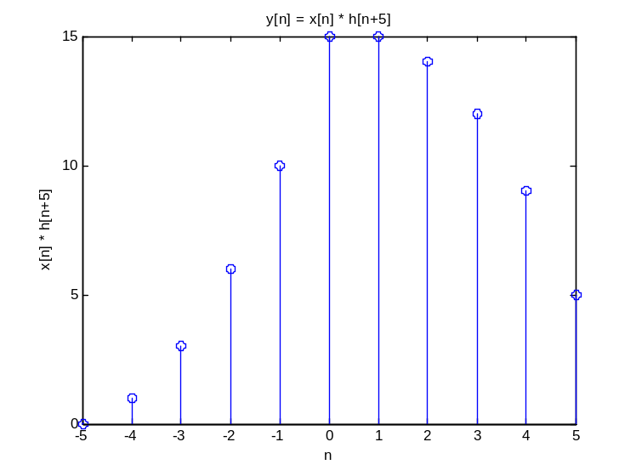
20494846
2.2
a.
a1 = [1];
b1 = [0.5 1 2];

b.
a2 = [1 -0.8];
b2 = [2];

c.
a3 = [1 -0.8];
b3 = [0 2];

d.
a1 = [1];
b1 = [0.5 1 2];

a2 = [1 -0.8];
b2 = [2];

a3 = [1 -0.8];
b3 = [0 2];

x = [1 2 3 4];

y1 = filter(b1,a1,x)
y2 = filter(b2,a2,x)
y3 = filter(b3,a3,x)
sonuçlar :

y1 =

0.5000 2.0000 5.5000 9.0000

y2 =

2.0000 5.6000 10.4800 16.3840

y3 =

0 2.0000 5.6000 10.4800
20494846
2.7

a.
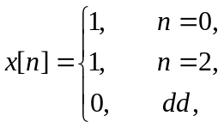
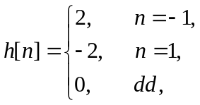
y[n] = x[n] * h[n] 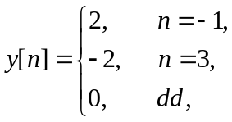

h = [0 2 0 -2 0 0 0];
x = [0 0 1 0 1 0 0];
ny = [-4:8]
y = conv(x,h);
stem(ny,y)
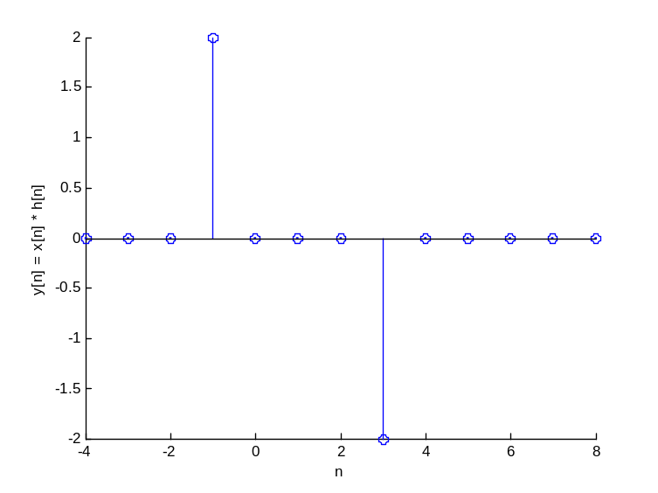
20494846
3.13
b.

ezplot('H',[-100*pi 100*pi])
>> syms w
>> R=10;
>> L=1;
>> H=R/(R+j*w*L);
>> ezplot('H')
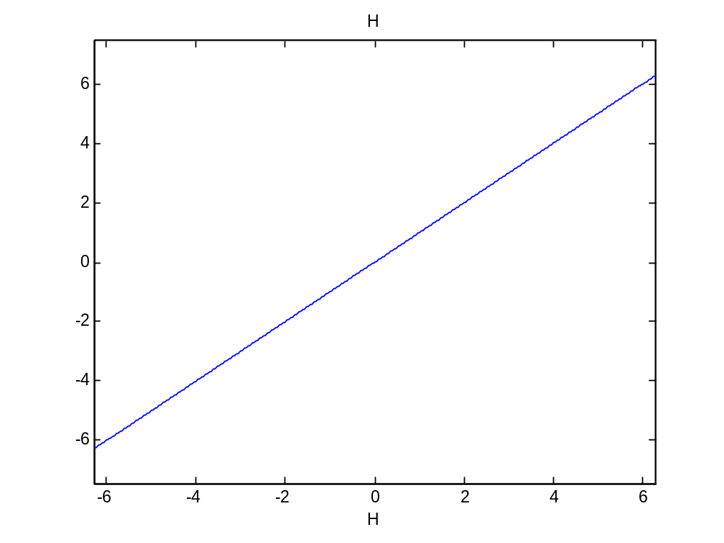 M=sqrt((10^4+10^2*w^2)/(100+w^2)^2); %magnitude
>> ezplot('M')

20494846
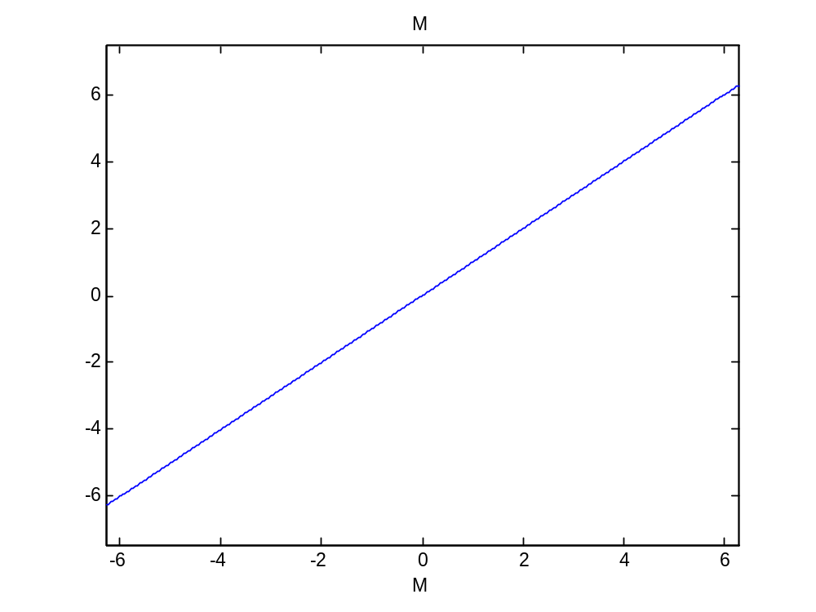>> P=atan(w/10);
>> ezplot('P')
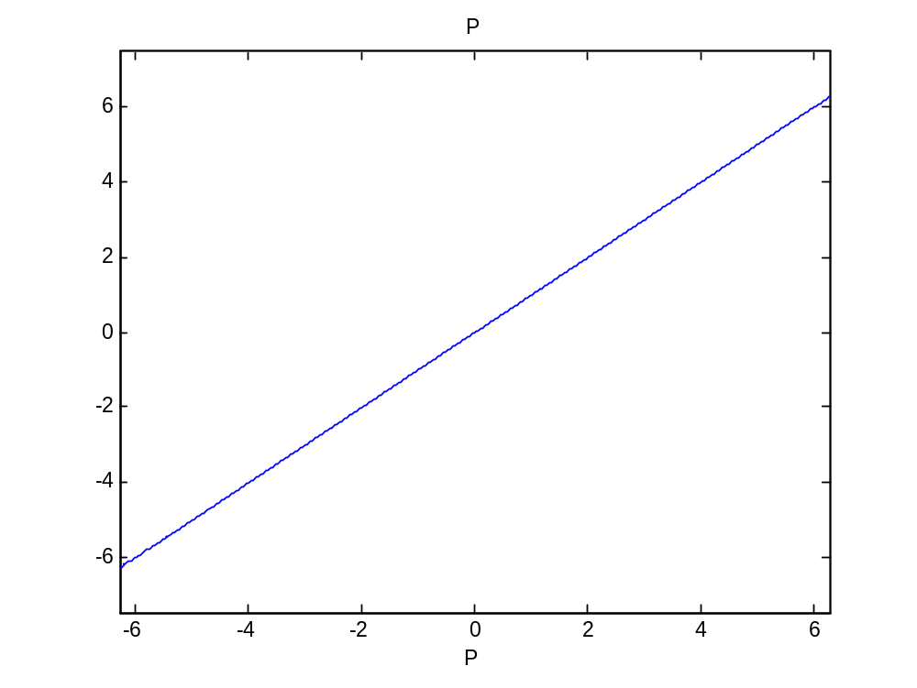
20494846

3.2

a.

a=[1 -0.8];
b= [2 0 -1];

N=[0 pi/4 pi/2 3*pi/4];
[H1 omega1] = freqz(b,a,N,'whole')

b.

H1 =

5.0000 2.8200 - 1.3705i 1.8293 - 1.4634i 0.9258 - 0.9732i

omega1 =

0 0.7854 1.5708 2.3562

c.

a=[1 -0.8];
b= [2 0 -1];

N=[0 pi/2 pi 3*pi/2];

[H1 omega1] = freqz(b,a,N,'whole')

H2 =

5.0000 1.8293 - 1.4634i 0.5556 - 0.0000i 1.8293 + 1.4634i

omega2 =

0 1.5708 3.1416 4.7124

20494846
4.2

tau=0.01;
t = [0:tau:10-tau];

x= exp(-2*abs(t));

z=t-5;
y= exp(-2*abs(z));
Y= fftshift(tau*fft(y))

Y(jwk) değerleri hesaplandı.y vektöründe 1000 adet sample görüldü.

